Chestnuts and Buttercups Autumn Term Newsletter
We would like to wish all our families a big welcome (or welcome back!) to Grace Mary Primary School. We hope you all had a fantastic summer. This newsletter is designed to give you details about your child’s learning this term as well as other important information you need to be aware of. As always, please do not hesitate to speak to us with any questions or comments you may have. We really look forward to getting to know our children and supporting their learning and development.
Many thanks
Mrs Hardman, Mrs Purcell and Miss Garner (The Nursery Team)


Kind Reminders:
- Please could all children’s uniform be clearly labelled. Children are encouraged to bring spare clothes which can be kept in a bag on their peg.
- Children are welcome to bring in a snack from home however this snack must not contain nuts or sesame seeds. Can we kindly request that children do not bring sweets or chocolate into school.
- If your child is bringing grapes as a snack please can they be cut in half, lengthways.
- We spend a lot of time outdoors during the day. As the weather changes please ensure your child has appropriate clothing for the outdoors including coat, hat, and gloves when necessary. Children are welcome to bring in a pair of wellies to keep on their pegs to change in to.



Class Dojo:
Thank you to all parents who have signed up for our class dojo page. If you are experiencing any difficulties signing up, please let a member of staff know.
We will use our class dojo page to share information with parents and photographs of children’s experiences whilst at Nursery.



Amazing Autumn:
This term we will be exploring our school environment and observing the changes we are noticing. We will be thinking about Autumn and talking about seasons, looking at how leaves start to change and eventually fall from the trees. We would love to ask children to bring in natural things they might begin to find on walks or around their garden. This could be leaves, conkers, pinecones or any other things you discover.

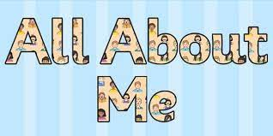

What will my child be learning?

Our first topic for the year is ‘All About Me! Children will be taking part in lots of activities to develop their knowledge and understanding of themselves, their families and each other. We will be talking about our likes, dislikes and interests, members of our families, our homes and our pets. We will focus heavily on building strong relationships with the children and encouraging them to build relationships with others. We will also invest a lot of time into ensuring children feel comfortable and confident to talk about and express their feelings within our setting. We will also learn about how to keep ourselves healthy and safe whilst at school.

Learning in the Early Years is split into seven different areas including; Communication and Language, Personal, Social and Emotional, Physical, Literacy, Mathematics, Understanding the World and Expressive Arts and Design. More information on our long- term planning and Nursery Curriculum can be found on the school website under Class Pages – Nursery. Below is a link to a useful document where you can find out more information on ‘what to expect and when’ in terms of your child’s development. We will work closely with your child to monitor their levels of development and support their learning. If you have any questions or concerns about your child’s development, please see a member of the EYFS team.

https://www.eyalliance.org.uk/sites/default/files/what_to_expect_when._a_parents_guide.pdf

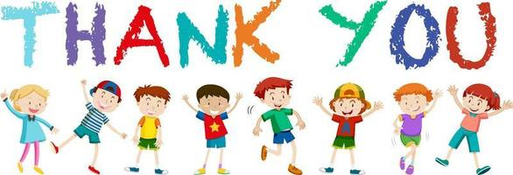

We have had a wonderful week getting to know all your amazing children. We have been so impressed with how they have settled in this week, and we are looking forward to a wonderful year. Thank you for continued support and please don’t hesitate to speak to us with any questions.

